**What is this repository for**

MMSC-GSNI is a modified method of similarity construction and the Gaver-Stehfest numerical inversion (MMSC-GSNI) algorithm program for solving fractal composite reservoir seepage model with polynomial type elastic outer boundary conditions.

The projection contains 12 files: posimn.m, beat1.m, epsilon.m, CDE2S.m, lambda.m, r1.m, RD.m, sigma.m, df1.m, df2.m, theta1.m, theta2.m.

posimn.m is a function file, the function is



where,  and  represent the initial and secondary categories of altered Bessel functions of order , respectively. This function is mainly used to simplify the expression of bottomhole pressure in in fractal composite reservoir seepage model with polynomial type elastic outer boundary conditions.

beat1.m, epsilon.m, CDE2S.m, lambda.m, r1.m, RD.m, sigma.m, df1.m, df2.m, theta1.m and theta2.m are all command files. Their main purposes are to use MMSC-GSNI algorithm to obtain non-dimensional bottomhole pressures and their derivatives in fractal composite reservoir seepage model with polynomial type elastic outer boundary conditions under different quadratic pressure gradients , non-dimensional elasticity , non-dimensional parameter cluster , non-dimensional coefficient , non-dimensional inner radius , non-dimensional outer radius , non-dimensional parameter , non-dimensional fractal dimensions  and , non-dimensional fractal indexes  and .

TEST DATA

Command files beat1.m, epsilon.m, CDE2S.m, lambda.m, r1.m, RD.m, sigma.m, df1.m, df2.m, theta1.m and theta2.m already contain test data, which can be directly run to obtain test results.

**Usage**

For users with MATLAB:

(1) Open epsilon.m, click "run" on the menu above MATLAB to start running, the program ends, and a figure pops up, which shows non-dimensional bottomhole pressure and its derivative cures in fractal composite reservoir seepage model with polynomial type elastic outer boundary conditions under different non-dimensional elasticity .

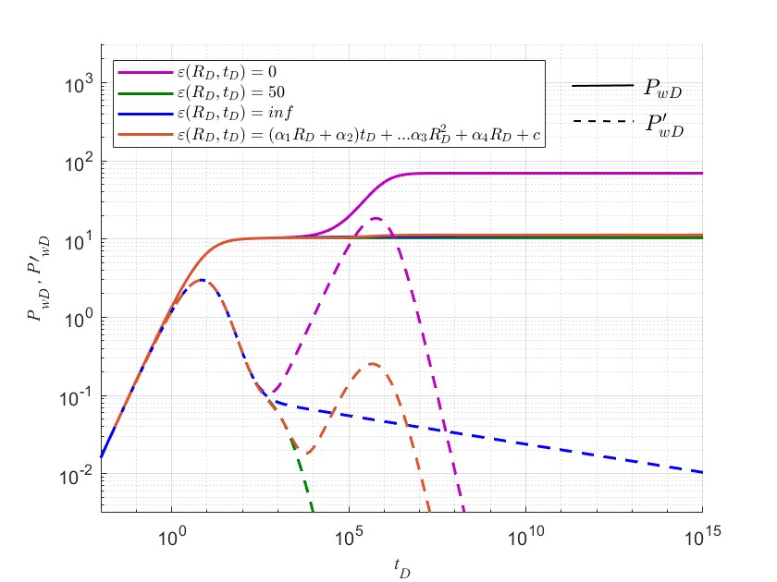

(2) Open beat1.m, click "run" on the menu above MATLAB to start running, the program ends, and a figure pops up, which shows non-dimensional bottomhole pressure and its derivative cures in fractal composite reservoir seepage model with polynomial type elastic outer boundary conditions under different quadratic pressure gradients .

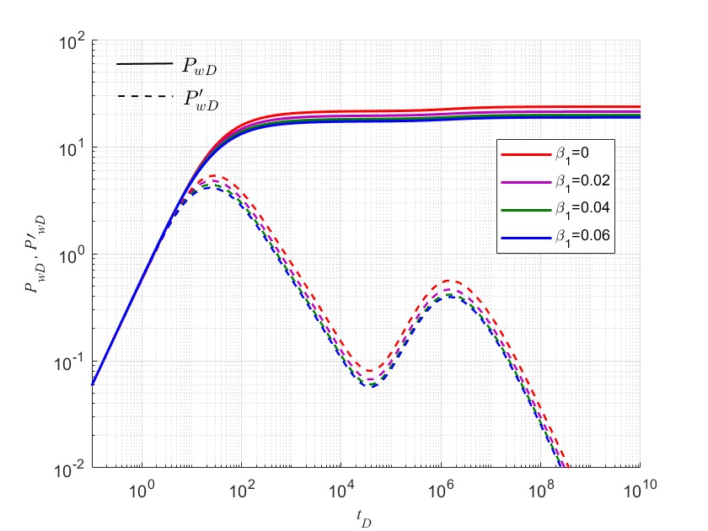

(3) Open CDE2S.m, click "run" on the menu above MATLAB to start running, the program ends, and a figure pops up, which shows non-dimensional bottomhole pressure and its derivative cures in fractal composite reservoir seepage model with polynomial type elastic outer boundary conditions under different non-dimensional parameter cluster .

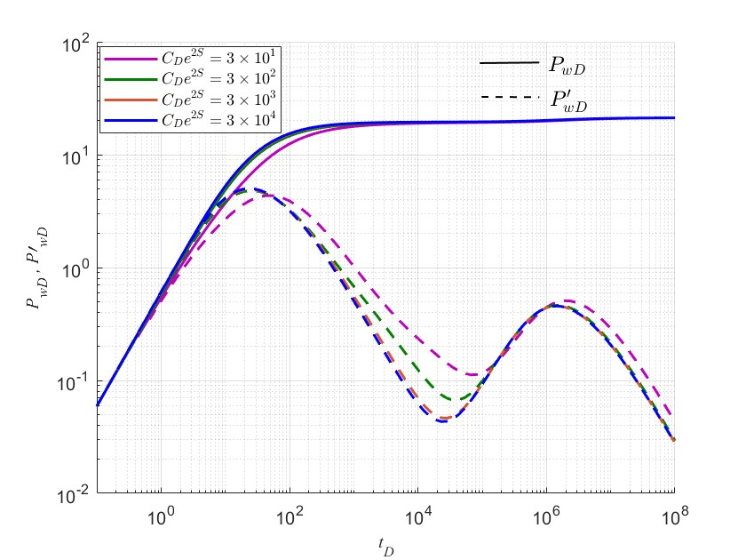

(4) Open lambda.m, click "run" on the menu above MATLAB to start running, the program ends, and a figure pops up, which shows non-dimensional bottomhole pressure and its derivative cures in fractal composite reservoir seepage model with polynomial type elastic outer boundary conditions under different non-dimensional coefficient .

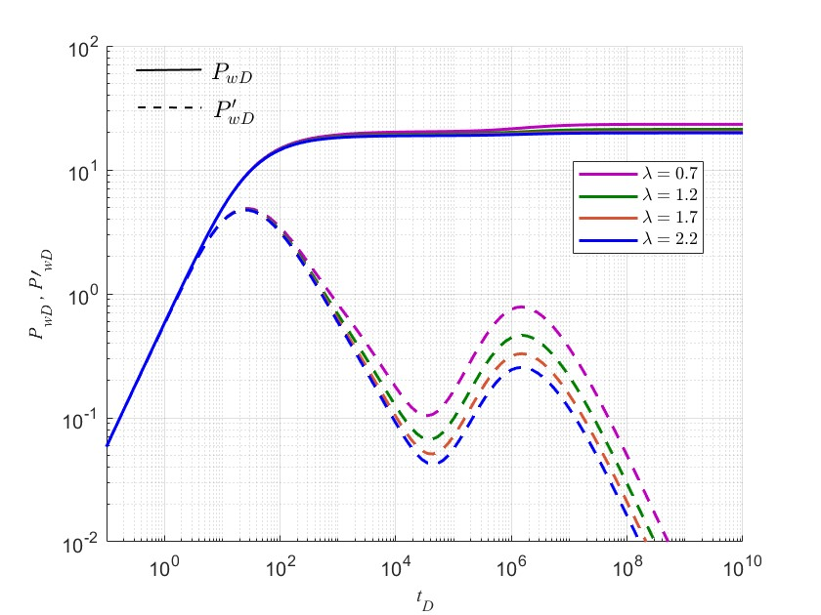

(5) Open r1.m, click "run" on the menu above MATLAB to start running, the program ends, and a figure pops up, which shows non-dimensional bottomhole pressure and its derivative cures in fractal composite reservoir seepage model with polynomial type elastic outer boundary conditions under different non-dimensional inner radius .

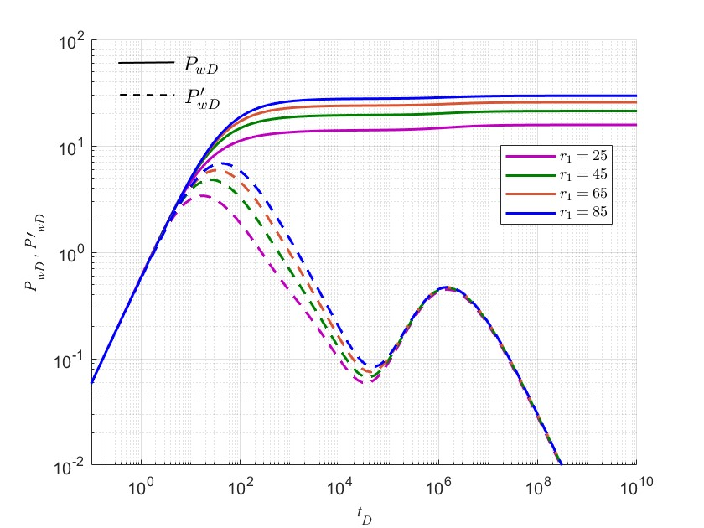

(6) Open RD.m, click "run" on the menu above MATLAB to start running, the program ends, and a figure pops up, which shows non-dimensional bottomhole pressure and its derivative cures in fractal composite reservoir seepage model with polynomial type elastic outer boundary conditions under different non-dimensional outer radius .

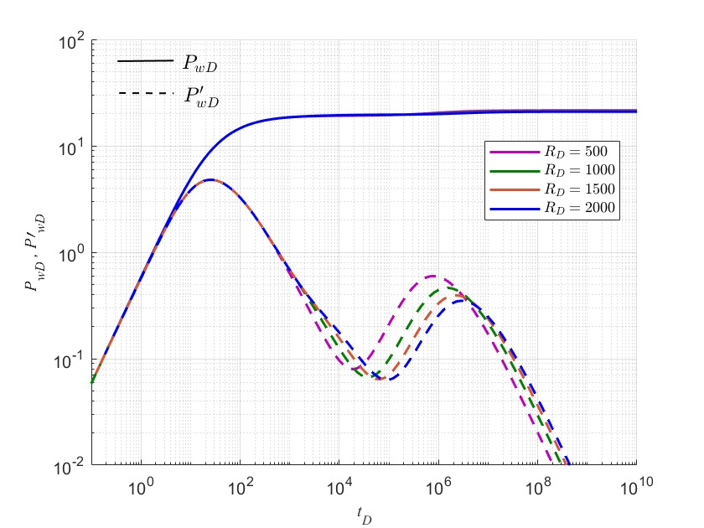

(7) Open sigma.m, click "run" on the menu above MATLAB to start running, the program ends, and a figure pops up, which shows non-dimensional bottomhole pressure and its derivative cures in fractal composite reservoir seepage model with polynomial type elastic outer boundary conditions under different non-dimensional parameter .

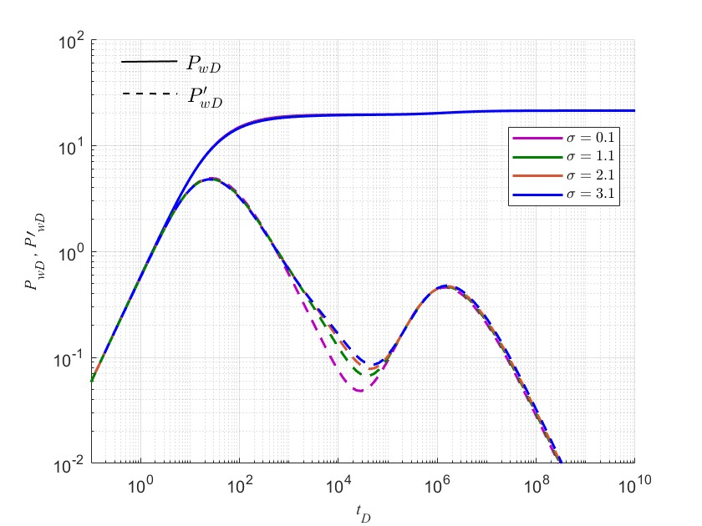

(8) Open df1.m, click "run" on the menu above MATLAB to start running, the program ends, and a figure pops up, which shows non-dimensional bottomhole pressure and its derivative cures in fractal composite reservoir seepage model with polynomial type elastic outer boundary conditions under different non-dimensional fractal dimensions .

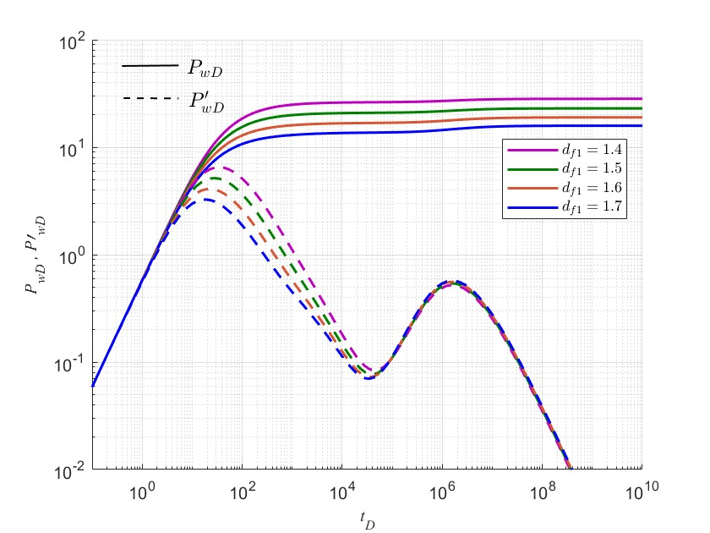

(9) Open df2.m, click "run" on the menu above MATLAB to start running, the program ends, and a figure pops up, which shows non-dimensional bottomhole pressure and its derivative cures in fractal composite reservoir seepage model with polynomial type elastic outer boundary conditions under different non-dimensional fractal dimensions .

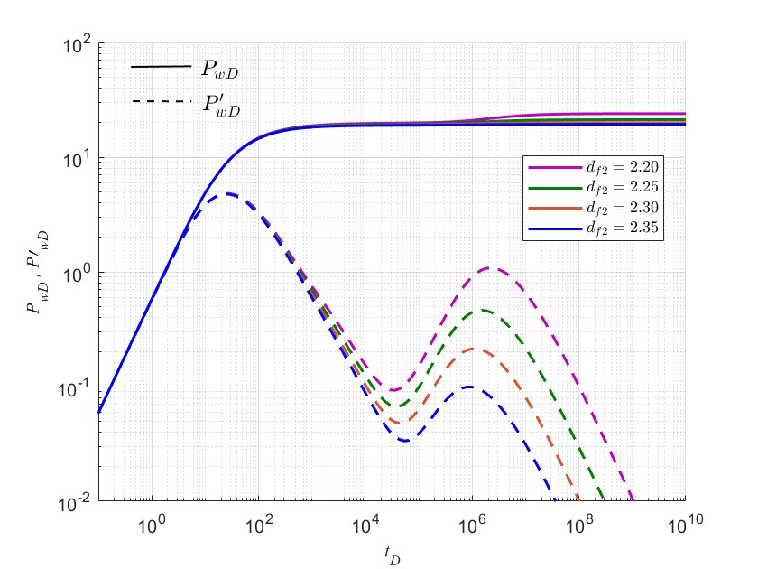

(10) Open theta1.m, click "run" on the menu above MATLAB to start running, the program ends, and a figure pops up, which shows non-dimensional bottomhole pressure and its derivative cures in fractal composite reservoir seepage model with polynomial type elastic outer boundary conditions under different non-dimensional fractal indexes .

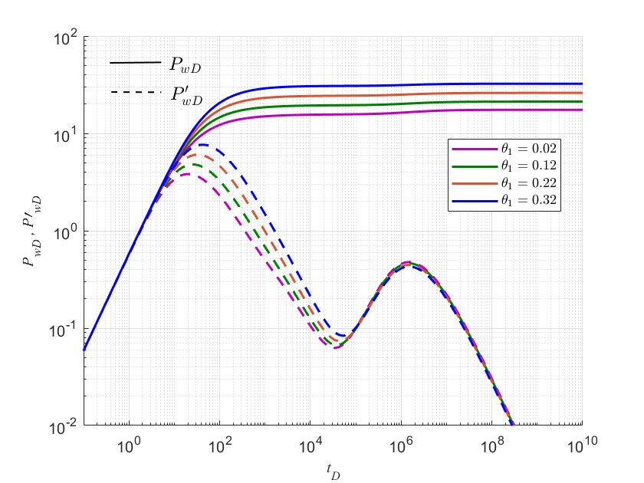

(11) Open theta2.m, click "run" on the menu above MATLAB to start running, the program ends, and a figure pops up, which shows non-dimensional bottomhole pressure and its derivative cures in fractal composite reservoir seepage model with polynomial type elastic outer boundary conditions under different non-dimensional fractal indexes .

